|  |  |
| --- | --- |
|  | Name: Ubaid ur Rehman  Class: BSCS-5B  Reg. #: 00000123495 |
|  |  |

# Task 1

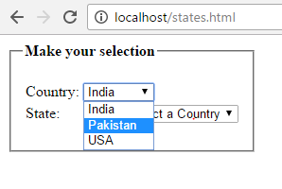

## Code:

<!DOCTYPE html>

<html>

<head>

<title>Country and State</title>

</head>

<body>

<fieldset style="width: 230px;">

<legend><strong>Make your selection</strong></legend>

<p>

<form name="test" method="POST" action="processingpage.php">

<table>

<tr>

<td style="text-align: left;">Country:</td>

<td style="text-align: left;">

<select name="country" id="country" onchange="setStates();">

<option value="India">India</option>

<option value="Pakistan">Pakistan</option>

<option value="USA">USA</option>

</select>

</td>

</tr>

<tr>

<td style="text-align: left;">State:</td>

<td style="text-align: left;">

<select name="state" id="state">

<option value="">Please select a Country</option>

</select>

</td>

</tr>

</table>

</form>

<p id="demo"></p>

</fieldset>

<script type="text/javascript">

function setStates(){

var xhttp = new XMLHttpRequest();

xhttp.onreadystatechange = function() {

if (this.readyState == 4 && this.status == 200) {

document.getElementById("demo").innerHTML = this.responseText;

// document.getElementById("state").innerHTML = jsonObj.document.getElementById("country").value;

document.getElementById("demo").innerHTML = jsonObj.India;

}

};

xhttp.open("GET", "http://http://localhost/data.json", true);

xhttp.send();

}

</script>

</body>

</html>

## Data.json:

{

"India" : ["Andhra Pradesh", "Assam", "Bihar", "Chhattisgarh", "Goa", "Gujarat", "Haryana"],

"Pakistan" : ["Balochistan", "Gilgit Baltistan", "Khaber Pakhtoonkhah", "Punjab", "Sindh"],

"USA" : ["California","Florida","New York"]

}

# Task 2

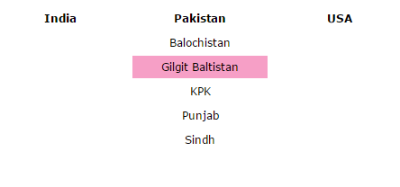

## Code:

<!DOCTYPE html>

<html>

<head>

<title>Dropdown Countries and States</title>

<script type="text/javascript" src="jquery.js"></script>

<script type="text/javascript">

$(function(){

$('.dropdown').mouseenter(function(){

$('.sublinks').stop(false, true).hide();

var submenu = $(this).parent().next();

submenu.css({

position:'absolute',

top: $(this).offset().top + $(this).height() + 'px',

left: $(this).offset().left + 'px',

zIndex:1000

});

submenu.stop().slideDown(400);

submenu.mouseleave(function(){

$(this).slideUp(400);

});

});

});

</script>

<style type="text/css">

ul{

list-style:none;

padding:0px;

margin:0px

}

ul li{

float:left;

}

ul li a{

color:#000;

margin-right:5px;

font-weight:bold;

font-size:12px;

font-family:verdana;

text-decoration:none;

display:block;

width:150px;

height:25px;

line-height:25px;

text-align:center;

}

ul li a:hover{

color:#000;

font-weight:bold;

text-decoration:none;

display:block;

width:150px;

text-align:center;

}

ul li.sublinks a{

color:#000000;

font-weight:normal;

text-decoration:none;

display:block;

width:150px;

text-align:center;

margin-top:2px;

}

ul li.sublinks a:hover{

color:#000000;

background:#F69FC6;

font-weight:normal;

text-decoration:none;

display:block;

width:150px;

text-align:center;

}

ul li.sublinks{

display:none;

}

#container{

margin:0px auto;

width:570px;

}

</style>

</head>

</head>

<body>

<div id="container" style="margin-top:40px;">

<ul>

<li><a href="#" class="dropdown">India</a></li>

<li class="sublinks">

<a>Andhra Pradesh</a>

<a>Assam</a>

<a>Bihar</a>

<a>Chhattisgarh</a>

<a>Goa</a>

<a>Gujarat</a>

<a>Haryana</a>

</li>

</ul>

<ul>

<li><a href="#" class="dropdown">Pakistan</a></li>

<li class="sublinks">

<a>Balochistan</a>

<a>Gilgit Baltistan</a>

<a>KPK</a>

<a>Punjab</a>

<a>Sindh</a>

</li>

</ul>

<ul>

<li><a href="#" class="dropdown">USA</a></li>

<li class="sublinks">

<a>California</a>

<a>Florida</a>

<a>New York</a>

</li>

</ul>

</div>

</body>

</html>